3. Install VirtualBox / VMware Workstation with different flavors of Linux or Windows OS on top of Windows 8 or above.

Aim:- To install Oracle VirtualBox on a Windows system and setup Ubuntu 24.04.3 LTS as a virtual machine for testing and usage.



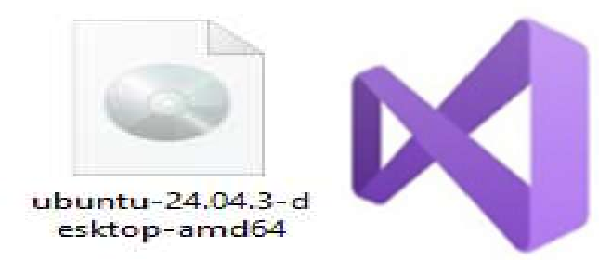
Requirements:-
-ChromeBrowserandMicrosoftVisualC++
-OracleVirtualBoxandUbuntuISOFile

Steps To Installation VirtualBox:-
Step-1:Downloading Oracle Virtual Box on Windows
Go to the Chrome browser and search for “VirtualBox”, then open the official Oracle VirtualBox website, click on the Download button, choose Windows Hosts from the available options, and the executable file will be downloaded to your system.
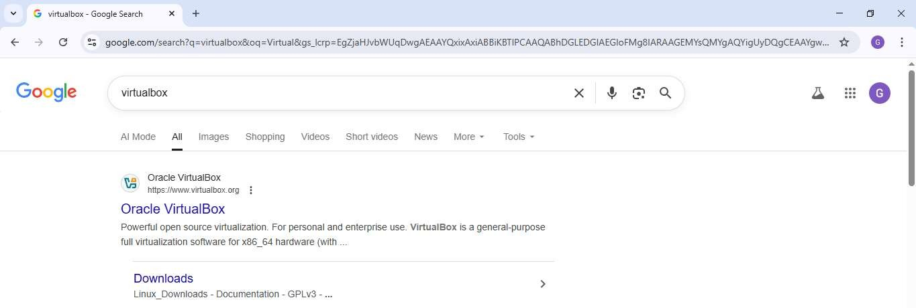
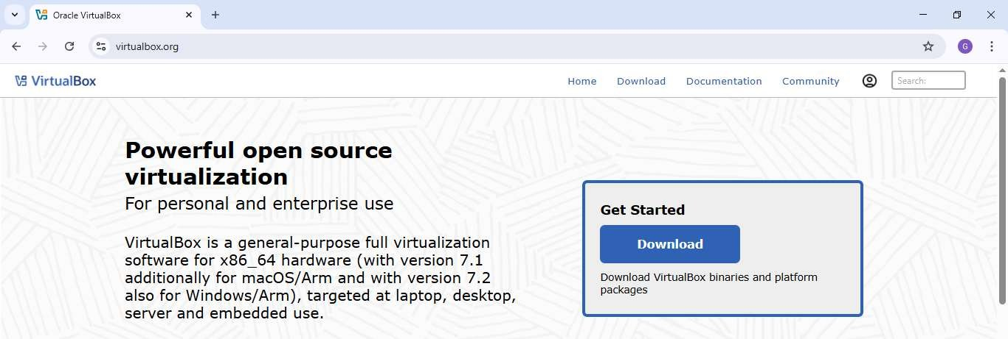
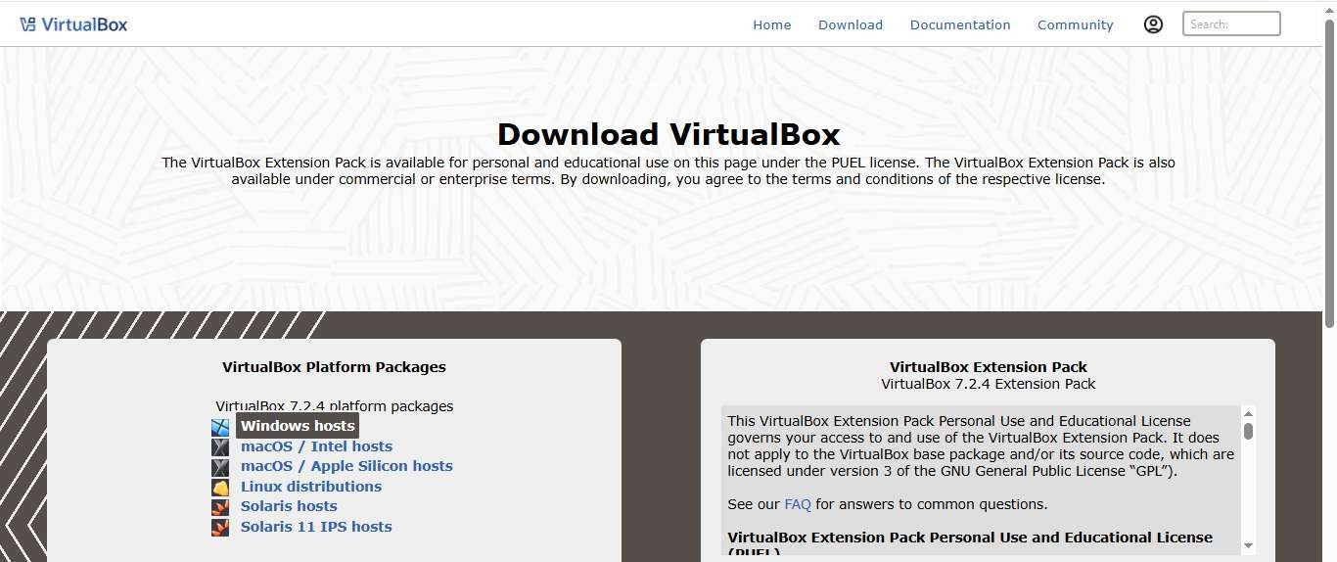

Step-2:Installing OracleVirtual Box on Windows
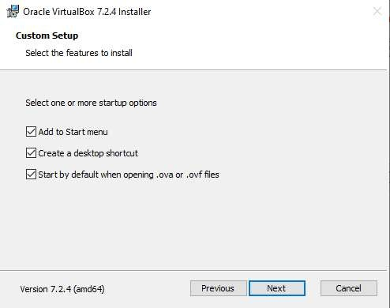
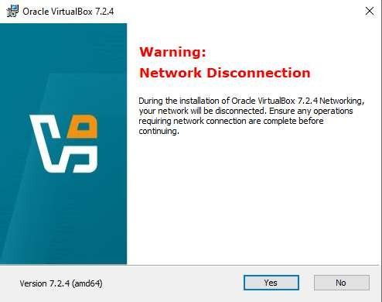
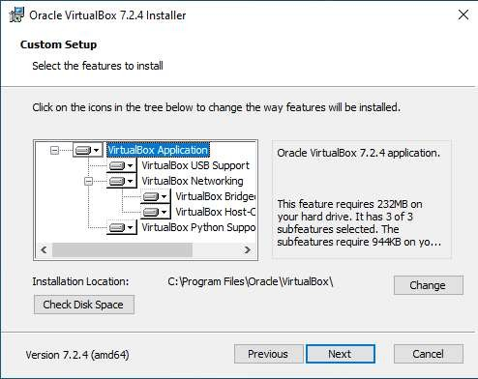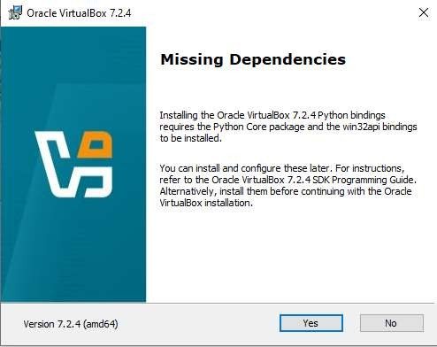Click the downloaded executable file → the setup window opens → click Next → select “I accept the terms in the License Agreement” → click Next → in Setup / File Location, keep the default settings → click Next → click Yes → click Yes → in Custom Setup, keep the default options → click Next → click Install → after successful installation, click Finish to complete the process.

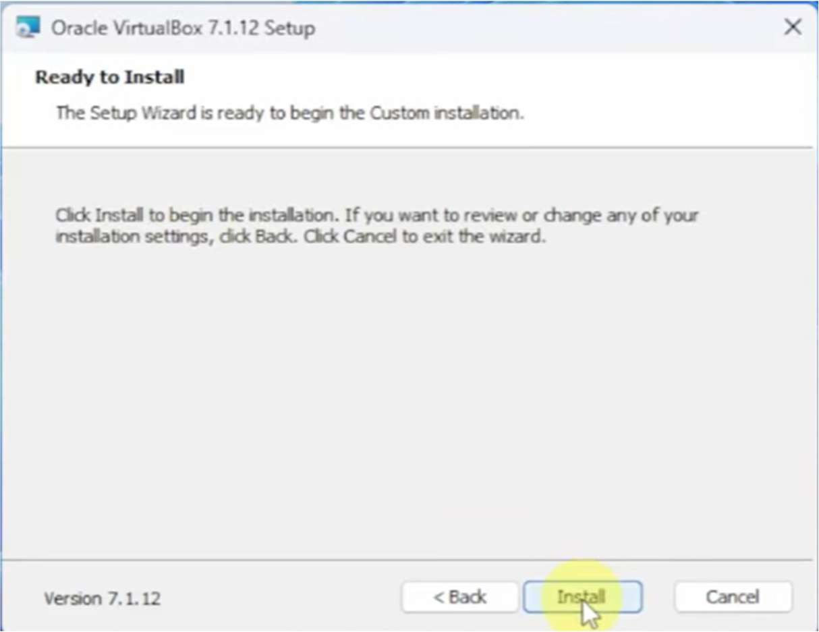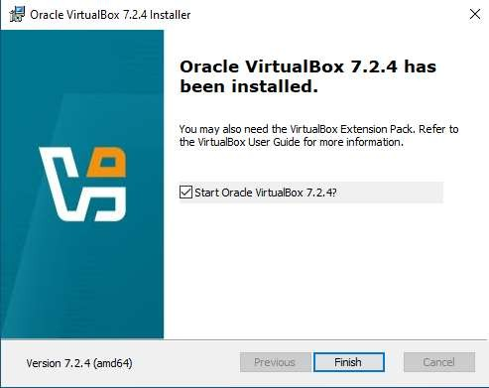

The interface will look like this.
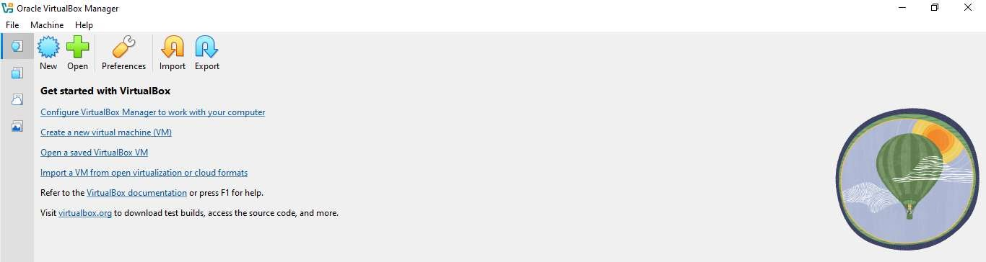

Note:-PrerequisiteRequirement
Before installing VirtualBox, ensure that Microsoft Visual C++ 2019 is already installed on your system.

StepsToInstallationOfUbuntu:-
Step-1:DownloadingUbuntuDesktopISO
Go to the Chrome browser and search for Ubuntu, open the official website ubuntu.com, navigate to Products
→UbuntuDesktop,clickDownloadUbuntuDesktop,scrolltofindUbuntu24.04.3LTS,andclickthe
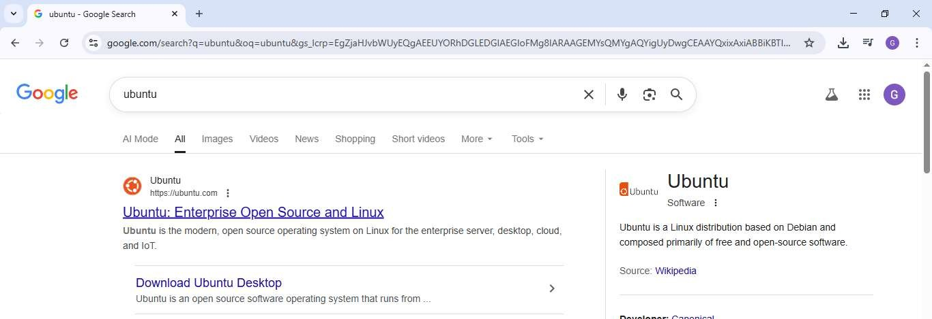
DownloadbuttontostartdownloadingtheISOfile.

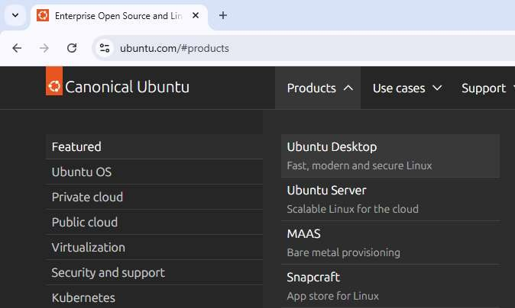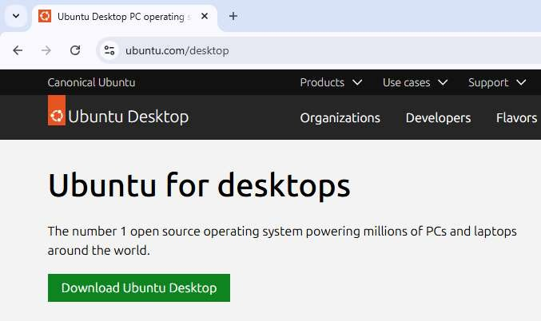
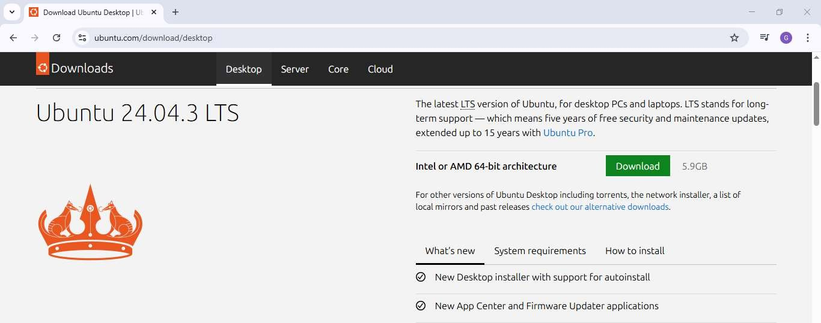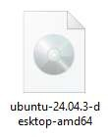
Installation Of Ubuntu On VirtualBox:-
Step-1:CreatingaNewVirtual Machine in VirtualBox
Open VirtualBox, click New, fill in the required fields as shown in the image, and browse to select the Ubuntu ISO file from the Downloads folder.
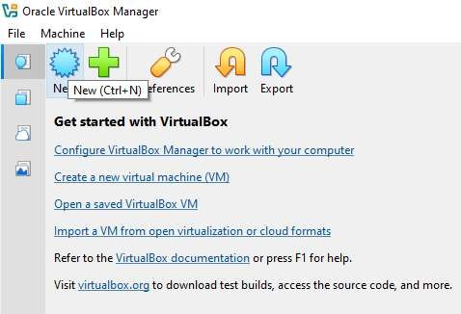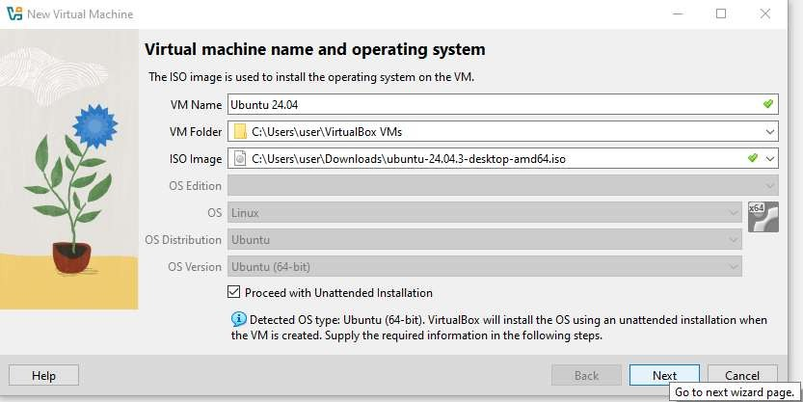

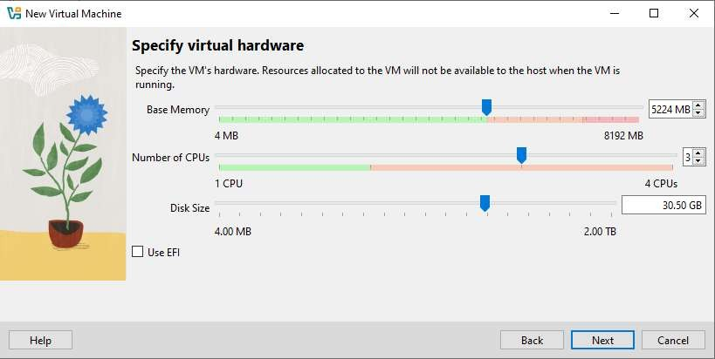
Step-2:ConfiguringUserDetailsandHostname
Enter the username and password, change the hostname from Ubuntu 24.04 to Ubuntu, and tick the checkbox to Install Guest Additions.
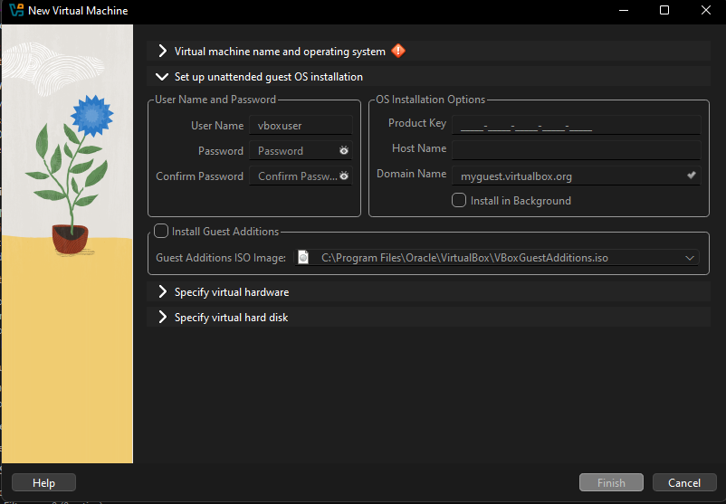

Step-3:ConfiguringVirtualHardwareandFinalizingSetup
Click Next, then in the Specify Virtual Hardware window, adjust the Base Memory, Number of CPUs, and Disk Size as shown, click Next, review your settings in the Summary window, and click Finish to complete the virtual machine setup.

Step-4:LaunchingUbuntuinVirtualBox
The Ubuntu OS is now added to VirtualBox. When you open it for the first time, it will start normally. On subsequent launches, it will prompt you to enter the password you created during setup.
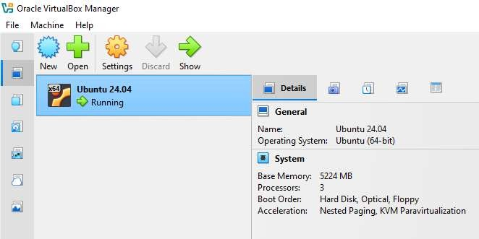
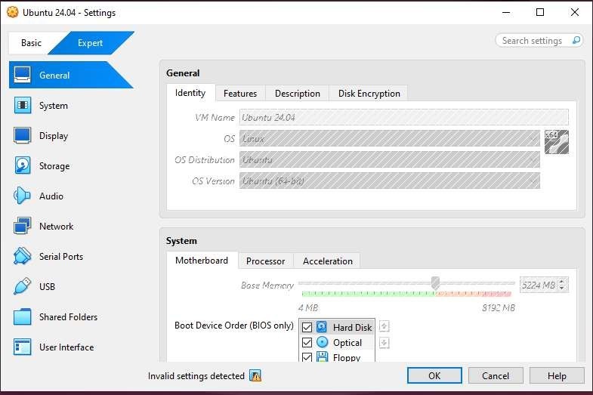

Conclusion:-

- InstallingVirtualBoxenablesrunningUbuntuonaWindowssystemwithoutaffectingthemainOS.
- ConfiguringthevirtualmachineandinstallingGuestAdditionsimprovesperformanceandusability.
- Thissetupprovidesasafeandefficientenvironmentforlearning,development,andtesting.

